**Homework 7**

Jiaqi Li

**1.----------------------------------------------------------------------------------------------------------------------------------------**

**(a)**

Yijt = μ + αi + βj + (αβ)ij + ϵijt, ϵijt ∼ N(0, σ2) with iid.

τij = αi + βj + (αβ)ij

i=control, f1, f2, f3 j=SppA, SppB t=1, 2, 3, 4, 5, 6

**(b)**

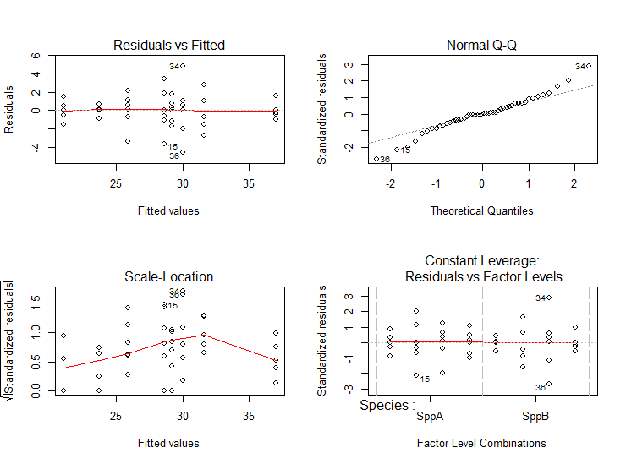

By observing the scatter plot, we conclude that residuals do not have constant variance. By observing the Q-Q plot, we conclude that some points in the plot do not fit the line well, which indicates the violation of normality. Thus, we choose to transform the response.

> modelF3<-aov(LogH~Fert+Species+Fert:Species, data=df)

> par(mfrow=c(2,2))

> plot(modelF3)

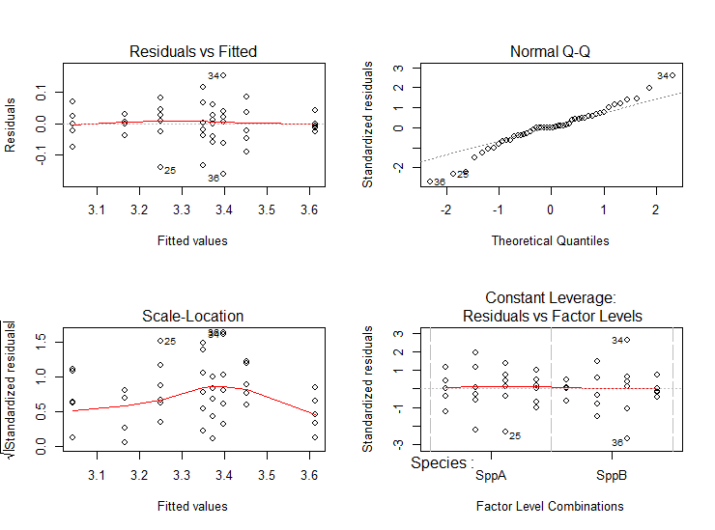

We use the new model (coded as modelF3 in R):

Log(Yijt) = μ + αi + βj + (αβ)ij + ϵijt, ϵijt ∼ N(0, σ2) with iid.

τij = αi + βj + (αβ)ij

i=control, f1, f2, f3 j=SppA, SppB t=1, 2, 3, 4, 5, 6

In the model, we observe that residuals still have non-constant variance and data do not fit the line well enough in the Q-Q plot, which indicates violation of normality. However, this transformation is better than the un-transformed model. Thus, we use this transformation as our model to make further study and we need to be careful with the p-value our hypothesis tests calculating for us because assumptions for error terms are not satisfied.

**(c)**

> anova(modelF3)

Analysis of Variance Table

Response: LogH

Df Sum Sq Mean Sq F value Pr(>F)

Species 1 0.27920 0.27920 66.6636 4.733e-10 ***

Fert 3 0.99025 0.33008 78.8131 < 2.2e-16 ***

Species:Fert 3 0.03319 0.01106 2.6417 0.06241 .

Residuals 40 0.16753 0.00419

---

Signif. codes: 0 ‘***’ 0.001 ‘**’ 0.01 ‘*’ 0.05 ‘.’ 0.1 ‘ ’ 1

**For interaction:**

H0: there is no interaction effect on the mean height.

H1: there are some interaction effects on the mean height.

p-vlaue=0.06241 > α = 0.05

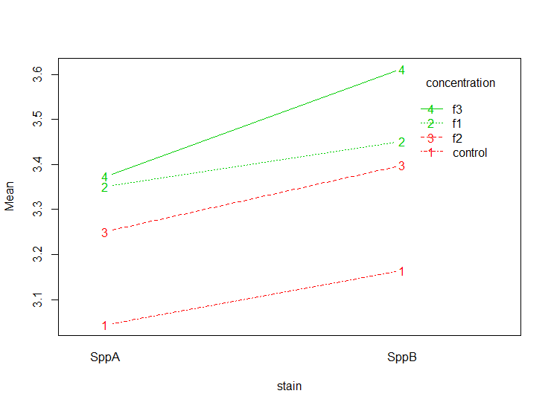Thus, we fail to reject hull hypothesis and conclude that there is no interaction effect on the mean height.

Since assumptions for error terms are not satisfied, we suspect the accuracy of the p-value calculated by this model and we should always suspect the accuracy of the conclusion that there is no interaction effect.

**For “Species”:**

H0: species has no effect on mean height. H1: species has effects on mean height.

p-vlaue=4.733 × 10-10 < α = 0.05

Thus, we reject hull hypothesis and conclude that species has effects on the mean height.

> contrast(lsmS, method="pairwise")

contrast estimate SE df t.ratio p.value

SppA - SppB -0.1525338 0.01868192 40 -8.165 <.0001

Results are averaged over the levels of: Fert

p-value < 0.0001 < α = 0.05

Thus, species SppB has more effect on the mean height than SppA has.

**For “Fert”:**

H0: fertilizers have no effect on mean response. H1: at least one fertilizer has effect on mean height.

p-vlaue < 2.2 × 10-16 < α = 0.05

Thus, we reject hull hypothesis and conclude that at least one fertilizer has effect on the mean height.

> contrast(lsmF, method="pairwise")

contrast estimate SE df t.ratio p.value

control - f1 -0.29674566 0.02642023 40 -11.232 <.0001

control - f2 -0.22001603 0.02642023 40 -8.328 <.0001

control - f3 -0.38849410 0.02642023 40 -14.704 <.0001

f1 - f2 0.07672963 0.02642023 40 2.904 0.0292

f1 - f3 -0.09174844 0.02642023 40 -3.473 0.0066

f2 - f3 -0.16847806 0.02642023 40 -6.377 <.0001

Results are averaged over the levels of: Species

P value adjustment: tukey method for comparing a family of 4 estimates

To observe easier, we can do the following:

> cld(lsmF, alpha=0.05)

Fert lsmean SE df lower.CL upper.CL .group

control 3.104426 0.01868192 40 3.066669 3.142184 1

f2 3.324442 0.01868192 40 3.286685 3.362200 2

f1 3.401172 0.01868192 40 3.363415 3.438930 3

f3 3.492921 0.01868192 40 3.455163 3.530678 4

From the table above, we see that all p-values of the contrast are smaller than α = 0.05. Thus we conclude that:

* f1 has more effect on the mean height than the control group has.
* f2 has more effect on the mean height than the control group has.
* f3 has more effect on the mean height than the control group has.
* f1 has more effect on the mean height than f2 has.
* f3 has more effect on the mean height than f1 has.
* f3 has more effect on the mean height than f2 has.
* No other significant pairwise differences in mean height with respect to different fertilizers.

**2.----------------------------------------------------------------------------------------------------------------------------------------**

**(a)**

Yijt = μ + αi + βj + (αβ)ij + ϵijt, ϵijt ∼ N(0, σ2) with iid.

τij = αi + βj + (αβ)ij

i=1, 2 j=1, 2 t=1, 2, 3, 4, 5

**(b)**

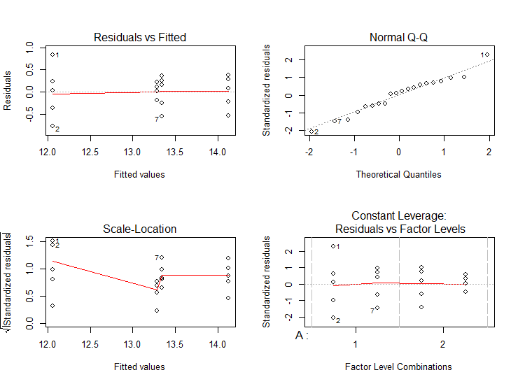

In the model, we observe that residuals do not have constant variance, but data fit the line well in the Q-Q plot, which indicates normality. In this model, assumptions of normality is satisfied but the constant variance is not satisfied. Then, we try to use transformation to satisfy error terms’ assumption of constant variance. However, none of the transformations makes any improvements. Thus, we use the un-transformed model for further study and we need to be careful with the p-value our hypothesis tests calculating for us because assumptions for error terms are not all satisfied. (Attempts of trying different transformations are included in R code at the last few pages and the outcomes are not shown in this report.)

(c)

> anova(model1)

Analysis of Variance Table

Response: resp

Df Sum Sq Mean Sq F value Pr(>F)

A 1 5.000 5.000 29.4118 5.632e-05 ***

B 1 0.242 0.242 1.4235 0.2502

A:B 1 5.618 5.618 33.0471 2.991e-05 ***

Residuals 16 2.720 0.170

---

Signif. codes: 0 ‘***’ 0.001 ‘**’ 0.01 ‘*’ 0.05 ‘.’ 0.1 ‘ ’ 1

**For intersection:**

H0: there is no interaction effect on the mean response.

H1: there are some interaction effects on the mean response.

p-vlaue=2.991 × 10-5 < α = 0.05

Thus, we reject hull hypothesis and conclude that there is some interaction effects on the mean response.

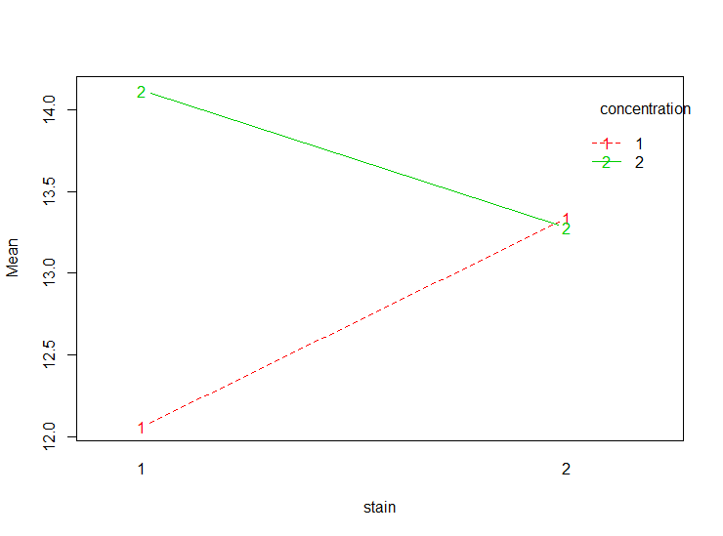

> lsmAB=lsmeans(model1, ~ A:B )

> contrast(lsmAB,method="pairwise")

contrast estimate SE df t.ratio p.value

1,1 - 2,1 -2.06 0.2607681 16 -7.900 <.0001

1,1 - 1,2 -1.28 0.2607681 16 -4.909 0.0008

1,1 - 2,2 -1.22 0.2607681 16 -4.678 0.0013

2,1 - 1,2 0.78 0.2607681 16 2.991 0.0389

2,1 - 2,2 0.84 0.2607681 16 3.221 0.0247

1,2 - 2,2 0.06 0.2607681 16 0.230 0.9955

P value adjustment: tukey method for comparing a family of 4 estimates

To observe easier, we can do the following:

> cld(lsmAB, alpha=0.05)

A B lsmean SE df lower.CL upper.CL .group

1 1 12.06 0.1843909 16 11.66911 12.45089 1

2 2 13.28 0.1843909 16 12.88911 13.67089 2

1 2 13.34 0.1843909 16 12.94911 13.73089 2

2 1 14.12 0.1843909 16 13.72911 14.51089 3

Confidence level used: 0.95

P value adjustment: tukey method for comparing a family of 4 estimates

significance level used: alpha = 0.05

We can conclude that:

* “A1 B1” has significantly lower mean than “A2 B2”, “A1 B2”, “A2 B1”.
* “A2 B2” has significantly lower mean than “A2 B1”.
* “A1 B2” has significantly lower mean than “A2 B1”.
* No other comparisons are significantly different than zero.

**For A:**

H0: A has no effect on mean response. H1: A has effects on mean response.

p-vlaue=5.632 × 10-5 < α = 0.05

Thus, we reject hull hypothesis and conclude that A has effects on the mean response.

> contrast(lsmA, method="pairwise")

contrast estimate SE df t.ratio p.value

1 - 2 -1 0.1843909 16 -5.423 0.0001

Results are averaged over the levels of: B

p-value = 0.0001 < α = 0.05

Thus, species A2 has more effect on the mean response than A1 has.

**For B:**

H0: B has no effect on mean response. H1: B has effects on mean response.

p-vlaue=0.2502 > α = 0.05

Thus, we fail to reject hull hypothesis and conclude that B does not have any effect on the mean response.

R code:

install.packages("lsmeans")

install.packages("multcompView")

install.packages("car")

library(lsmeans)

library(multcompView)

library(car)

options(contrasts = c("contr.sum", "contr.poly"))

#1-----------------------------------------------------------------------------------------------------------

Fert<-c(rep("control", 12), rep("f1", 12), rep("f2", 12), rep("f3", 12))

Species<-c(rep(c(rep("SppA", 6), rep("SppB", 6)),4))

Height<-c(21.0, 19.5, 22.5, 21.5, 20.5, 21.0,

23.7, 23.8, 23.8, 23.7, 22.8, 24.4,

32.0, 30.5, 25.0, 27.5, 28.0, 28.6,

30.1, 28.9, 30.9, 34.4, 32.7, 32.7,

22.5, 26.0, 28.0, 27.0, 26.5, 25.2,

30.6, 31.1, 28.1, 34.9, 30.1, 25.5,

28.0, 27.5, 31.0, 29.5, 30.0, 29.2,

36.1, 36.6, 38.7, 37.1, 36.8, 37.1)

df<-data.frame(Fert=Fert, Species=Species, Height=Height)

modelF1<-aov(Height~Fert+Species+Fert:Species, data=df)

par(mfrow=c(2,2))

plot(modelF1)

anova(modelF1)

df$LogH<-log(Height)

df$SqrtH<-sqrt(Height)

df$InvH<-1/Height

modelF2<-aov(SqrtH~Fert+Species+Fert:Species, data=df)

par(mfrow=c(2,2))

plot(modelF2)

modelF3<-aov(LogH~Fert+Species+Fert:Species, data=df)

par(mfrow=c(2,2))

plot(modelF3)

modelF4<-aov(InvH~Fert+Species+Fert:Species, data=df)

par(mfrow=c(2,2))

plot(modelF4)

anova(modelF3)

interaction.plot(x.factor = df$Species, trace.factor = df$Fert,

response = df$LogH, type ="b",col = 2:3,

xlab ="stain", ylab ="Mean", trace.label ="concentration")

lsmS=lsmeans(modelF3, ~Species)

contrast(lsmS, method="pairwise")

lsmF=lsmeans(modelF3, ~Fert)

contrast(lsmF, method="pairwise")

cld(lsmF, alpha=0.05)

#2-----------------------------------------------------------------------------------------------------------

A<-c(rep("1", 10), rep("2", 10))

B<-rep(c(c(rep("1", 5), rep("2", 5))), 2)

resp<-c(12.9, 11.3, 11.7, 12.1, 12.3,

13.7, 12.8, 13.6, 13.1, 13.5,

14.2, 14.5, 13.9, 13.6, 14.4,

13.5, 13.1, 13.3, 13.1, 13.4)

df2<-data.frame(A=A, B=B, resp=resp)

model1<-aov(resp~A+B+A:B, data=df2)

par(mfrow=c(2,2))

plot(model1)

df2$LogR<-log(resp)

df2$SqrtR<-sqrt(resp)

df2$InvR<-1/resp

model2<-aov(SqrtR~A+B+A:B, data=df2)

par(mfrow=c(2,2))

plot(model2)

model3<-aov(LogR~A+B+A:B, data=df2)

par(mfrow=c(2,2))

plot(model3)

model4<-aov(InvR~A+B+A:B, data=df2)

par(mfrow=c(2,2))

plot(model4)

anova(model1)

interaction.plot(x.factor = df2$B, trace.factor = df2$A,

response = df2$resp, type ="b",col = 2:3,

xlab ="stain", ylab ="Mean", trace.label ="concentration")

lsmAB=lsmeans(model1, ~ A:B )

contrast(lsmAB,method="pairwise")

cld(lsmAB, alpha=0.05)

lsmA=lsmeans(model1, ~A)

contrast(lsmA, method="pairwise")